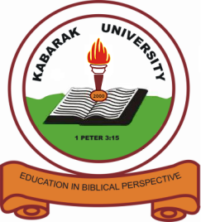

**KABARAK UNIVERSITY**

**SCHOOL OF SCIENCE ENGINEERING AND TECHNOLOGY**

**INTERNAL MEMO**

**TO:** ALL STAFF AND STUDENTS - SSET

**FROM:** DEAN **-** SCHOOL OF SCIENCE ENGINEERING AND TECHNOLOGY

**REF:** KABUO1/SSET/002/VOL.1

**DATE:** 2ND FEBRUARY 2024

**SUBJECT: DATA SCIENCE AND AI CONFERENCE OFFICIAL OPENING ON 6TH FEBRUARY 2024**

This is to invite all the staff and students of School Science, Engineering and Technology (SSET) to the official opening of conference on Tuesday, 6th February 2024 starting at 8.30 a.m. to 5.00 p.m. The Vice Chancellor Prof. Henry K. Kiplangat will officially officiate the opening ceremony.

I hereby suspend the all the classes on Tuesday, 06/02/2024 for the school of SSET to allow the members to converge in the Auditorium for official opening and to participate in this very important conference. Lecturers are requested to come with their students to sign the class attendance at the conference.

Thank you.



DR. PETER G. RUGIRI (PhD)

SENIOR LECTURER IN PURE MATHEMATICS

**DEAN – SCHOOL OF SCIENCE, ENGINEERING AND TECHNOLOGY**

***PGR/mb***

***CC:***Registrar (Academic and Research)

Dean’s of Schools

____________________________________________________________________________________________________________

### *Kabarak University Moral Code*

*As members of Kabarak University family, we purpose at all times and in all places, to set apart in one’s heart, Jesus as Lord. 1 Peter 3:15*



**KABARAK UNIVERSITY IS ISO 9001:2015 CERTIFIED**